**FINAL PAPER- LOST INTO THE WOODS**

Submitted By

Balaramakrishna Yadav Keerthi

Lokesh Gupta

Prem Sai Reddy Nallamalapu

Snigdha Sri Yalamarthi

Table of Contents

1.0 Introduction 2

1.1 Purpose 2

1.2 Problem Statement 2

2.0 Selection of Scenario for Game 2

3.0 User Manual and Screenshots of Game Interface 3

4.0 Challenges Faced During Project Activities 5

5.0 Benefits from Project Success 5

6.0 Limitation and Recommendation 6

7.0 Conclusion 6

# Introduction

## Purpose

Computational thinking deeply rooted with the conception and theory of computer application. Moreover, it conveys the competency of an individual to think in a critical manner so that one can resolve the problem emerges in the real-time application of IT based concepts. The purpose of this report is to reveal the mechanism that is being developed with an intention to create computational skill among the students.

## Problem Statement

Computational thinking motivates the student community to explore the technique to leverage technology in problem-solving the various academic real-time issues. On the other hand, the entertainment industries have introduced various unproductive games which actually providing no such vision. In the meantime, the IT applications used for gaming platforms are not properly integrated with the entertainment industry. Subsequently, the characteristics of game are either very dull or if it is interesting then it comes with unproductiveness. Hence, the fusion of entertainment and analytical skill attributes would give an effective resultant in the form of game that can resolve the above mentioned problem of analytical skill.

# Selection of Scenario for Game

We have been provided with 5 specific scenarios for games on behalf of the institution and each scenario inspire a student to think critically and computationally by incorporating the computer application theories and concept. It is a fact that our first priority was ‘Wandering in the Woods Game’ due to its characteristics that makes the project feasible to complete successfully. Most common factor among all the five scenarios of game was the divisions of students group into three segments on the basis of their grades. Hence, it was a challenge to decide to maintain the productiveness of game for grade k-2 and 8th standard student at the same time. After conducting a critical evaluation, our team has been realized that “Wandering in the Woods” or “lost in the woods” will be most suitable for all the students belongs to any level of grade. As a second choice, the “Traveling Salesperson Problem” has been selected and it would have been our project in case of cancellation of first priority of project. In this way, we found the “Exponential Simulation” very difficult and therefore, kept it as our last priority.

# User Manual and Screenshots of Game Interface

**Step1:** The Game ‘Lost in to the Woods’ will begin with clicking on the ‘Start’ option reflects on the interface. It also exhibits the level of difficulty that can be changed as per the requirement of player.

**Step 2:** The row and column ranges from 2 to 9and total player can play together in number ranges from 2 to 4.

**Step 3:** Ifplayerwants togoback then it‘MainMenu’ and if player clicks on the ‘Begin’ option, then, it will redirect toward Game.

**Step 4:** The character of the game would try tocatch another character moving on the ground surface of the screen**.**

**Step 5:** Once the player completed with game, then, the list of score will be generatedon the interface.

**Step 6:** The player can make exitfrom the main menu which is available on the Gaming interface of Score list.

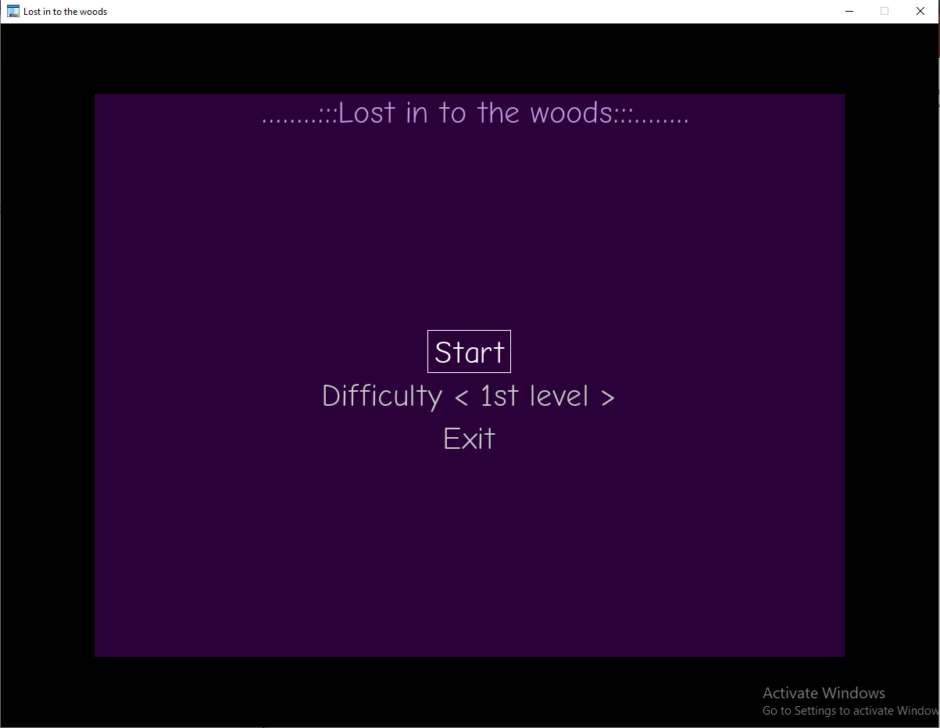

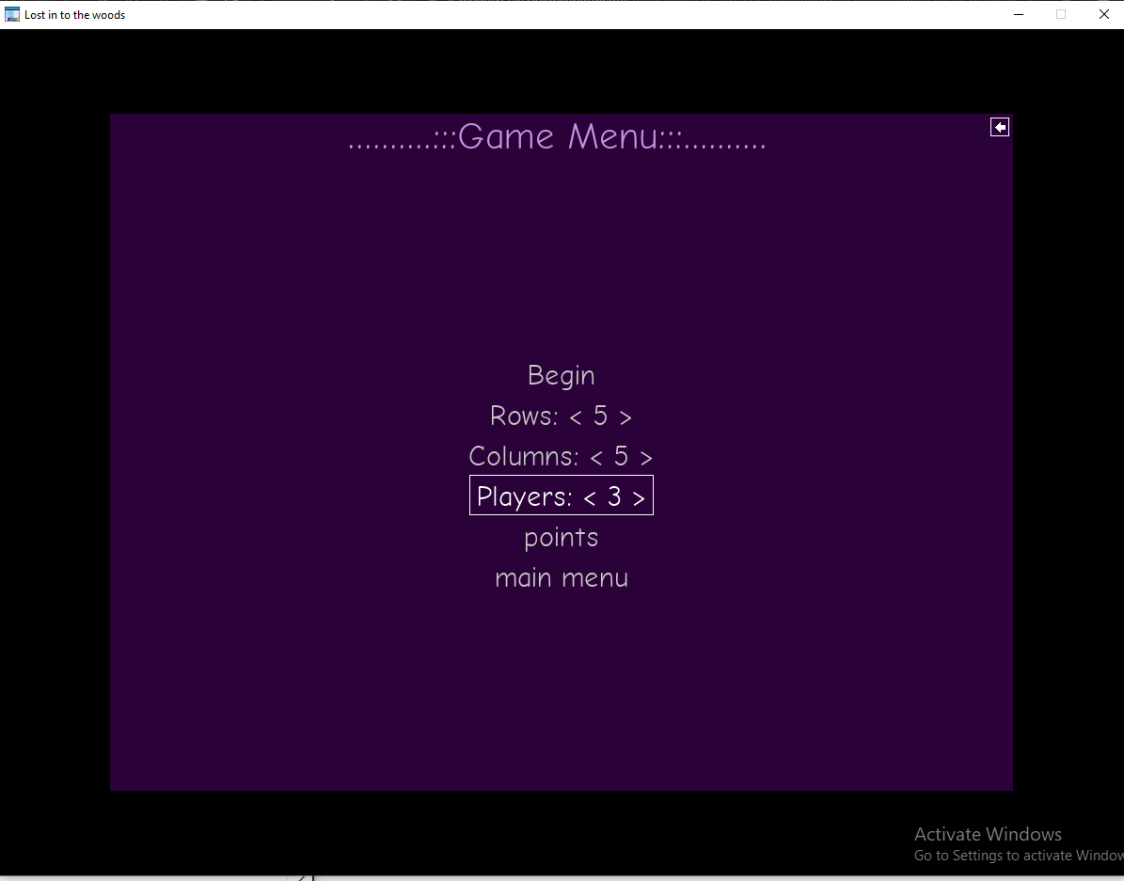

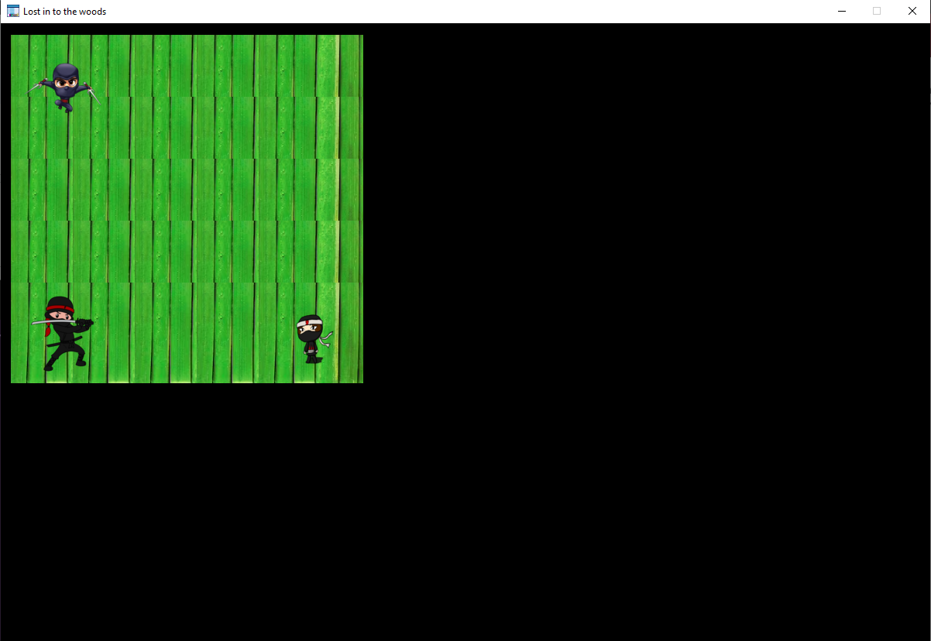

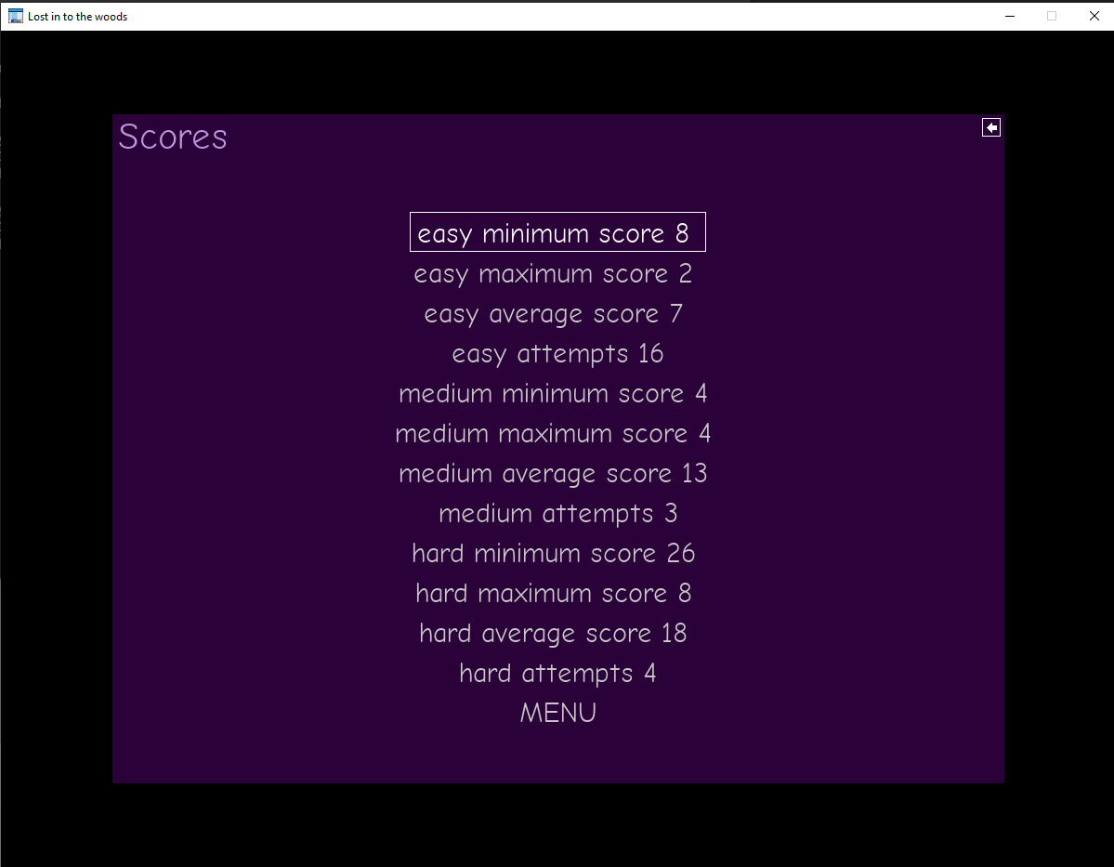

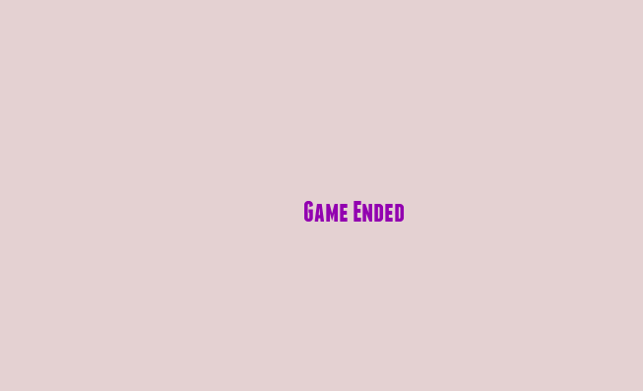

# Challenges Faced During Project Activities

We were very clear with our selection of game “Lost into the Woods” and we found it easier to work on the selected case scenario than other scenarios. Apart from few difficulties, our process of working on the project has taken place in a very smooth manner. As it is given in the case study that features of games belongs to Grade 6-to-8 is far complicated than second level (Grade 3-5) and therefore, we have faced issues from upgrading the second level to third level. It was difficult to put up logic through code to create three divisions in such a manner that it’s difficulty level will consecutively increases with respect to the increasing grades. However, our repeated attempt and conduction of critical thinking brought us to the stage.

# Benefits from Project Success

The project of Gaming application “Lost into the Woods” would give productive effect on the psychological state of student community. We have realized the change in our computational thinking process which not only created difference from other students but also inspire us to use it in real-time scenarios. With the success of this project, it is justified that a student can improve one’s analytical skill during an entertainment. In other words, this project depicts a new vision that can be integrated in the educational system for making the student competent for the IT industry. Likewise, the whole IT industry might get benefitted itself from this project by bringing the entertainment and learning on the common ground. Game developer gains a new perception to create a Gaming application which would provide them a customer base and allow them to hold the market more strongly. Apart from application and external benefits, an individual gets to an intellectual level where a highly complex thinking process can be achieved after playing this kind of games.

# Limitation and Recommendation

The productiveness of the project “Wander in the Wood Game” or “Lost into the Wood” has been proved with the help of facts and arguments. Moreover, it is our belief that no project can be flawless irrespective of its superiority of purpose or objective. Hence, this project also carries some limitations and that is its level. The project could have included the high school as fourth level of the game but it is our perception to limit the range of complexity level till third phase which needs to be improved. Our team member could have engaged with the lecturer of our institutions deeply in order to perceive more about the computational thinking. It could have helped us to present the same project in more high quality than it is now. Our approach should have included the advice of expert through survey process and it would have given us an idea about the application of computational thinking in the IT industry.

# Conclusion

From the above study, it has been concluded that the game “Lost into the Wood” has successfully possessed with features that can help a student from Grade K-2 to Grade 6-8 to improve their computational thinking process. It becomes clear with this project activities that the complexity level of game’s features depends on the maturity level of target audience and therefore, divisions of grades happened among the student community. The past score enlisted in the last phase of the game allows an individual to compare one’s computational thinking capability with other players.